WEEK 4 — MACHINE LEARNING MODEL DEVELOPMENT AND EVALUATION

Indian E-Commerce Sales Analytics Dataset
Internship: Yuva Intern – Virtual Data Science with Python Apprentice Intern
Source: Kaggle
Tools: Python, Jupyter Notebook, Pandas, Matplotlib, Seaborn, Squarify

1. Introduction

1.1 Project Overview
Week 4 focuses on applying supervised machine learning techniques to the Indian E-Commerce Sales dataset to develop a binary classification model for predicting order outcomes.
The prediction objective is to classify each order into one of two categories:
- Delivered — represented by 1
- Cancelled — represented by 0
Three classification algorithms were implemented and evaluated:
- Logistic Regression
- Decision Tree Classifier
- Random Forest Classifier
The models were evaluated using multiple performance measures, including Accuracy, Precision, Recall, F1 Score, Confusion Matrix, and ROC-AUC. Particular attention was given to class imbalance and potential data leakage to ensure that the final interpretation of model performance was reliable.

1.2 Problem Statement
Order cancellations can negatively affect revenue, inventory management, customer satisfaction, and operational planning. Therefore, identifying patterns associated with order cancellation can potentially support better business decision-making.
The dataset contained a significantly larger number of delivered orders than cancelled orders. Consequently, the problem represents an imbalanced binary classification task, requiring evaluation metrics beyond accuracy alone.

1.3 Project Objectives
The primary objectives of this analysis were to:
- Prepare the sales dataset for machine learning.
- Define order status as a binary target variable.
- Engineer and select relevant predictive features.
- Encode categorical variables into numerical representations.
- Address class imbalance using SMOTE.
- Train and compare three classification algorithms.
- Evaluate model performance using multiple classification metrics.
- Investigate potential data leakage.
- Develop a leakage-safe modeling approach.
- Interpret the results from both technical and business perspectives.

2. Dataset and Data Preparation

2.1 Dataset Description
The cleaned sales dataset contained 249,995 records and 22 variables.
For the classification task, only records having either Delivered or Cancelled as the order status were retained.
After filtering, the modeling dataset contained: 212,641 orders
The target distribution was:
Order Status | Number of Orders | Percentage
Delivered | 200,135 | 94.12%
Cancelled | 12,506 | 5.88%
Total | 212,641 | 100%
The target variable was encoded as follows:
Delivered → 1
Cancelled → 0

2.2 Feature Preparation
The initial model incorporated the following variables:
Feature | Description
Quantity | Number of items in the order
Unit_Price | Price per item
Order_Value | Value of the order before applicable adjustments
Shipping_Cost | Shipping charge associated with the order
Coupon_Discount | Discount obtained through a coupon
Total_Amount | Final order amount
Customer_Age | Age of the customer
Has_Review | Indicator of whether a review exists
Coupon_Used | Indicator of coupon usage
Delivery_Days | Number of days between order and delivery
Payment_Mode | Payment method selected
State | Customer's state
Customer_Age_Group | Age category of the customer
Categorical variables were converted into numerical form using Label Encoding.
The dataset was divided using an 80:20 train-test split with stratification to preserve the original class distribution.
Dataset | Records
Training Set | 170,112
Testing Set | 42,529
Numerical features were standardized using StandardScaler.

3. Handling Class Imbalance
The dataset exhibited considerable class imbalance, with cancelled orders representing only 5.88% of the observations.
To address this issue, Synthetic Minority Oversampling Technique (SMOTE) was applied to the training dataset.

Before SMOTE
Class | Count
Cancelled | 10,005
Delivered | 160,107

After SMOTE
Class | Count
Cancelled | 160,107
Delivered | 160,107
The test dataset was deliberately kept unchanged so that model performance could be evaluated using the original distribution of delivered and cancelled orders.

4. Model 1 — Logistic Regression

4.1 Model Description
Logistic Regression was selected as the baseline classification algorithm because of its simplicity, interpretability, and suitability for binary classification problems.
The model estimates the probability that an observation belongs to a particular class and assigns the corresponding class label based on the predicted probability.

4.2 Performance Results
Performance Metric | Score
Accuracy | 62.63%
Precision | 1.0000
Recall | 0.6029
F1 Score | 0.7523
ROC-AUC | 0.8034
The model achieved an ROC-AUC score of 0.8034, indicating moderate discriminative ability in the initial experiment. However, the class-specific results showed that cancelled orders were not identified reliably.

Interpretation
Logistic Regression provided a useful baseline but showed limited ability to capture the complex relationships associated with order outcomes. Although its precision was high, its recall indicated that a considerable proportion of observations were not correctly identified.

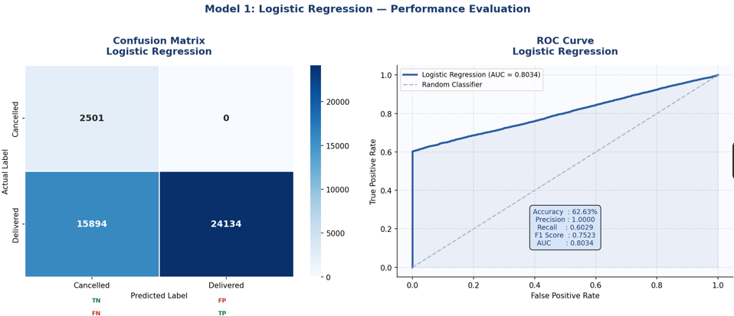
Figure 1: Logistic Regression — Confusion Matrix and ROC Curve

5. Model 2 — Decision Tree

5.1 Model Description
The Decision Tree Classifier was selected to capture nonlinear relationships between customer, order, payment, and transaction-related variables.
The model was constrained using maximum tree depth and minimum sample parameters to control excessive complexity.

5.2 Performance Results
Performance Metric | Score
Accuracy | 65.30%
Precision | 0.9919
Recall | 0.6366
F1 Score | 0.7755
ROC-AUC | 0.8010
The Decision Tree slightly improved upon Logistic Regression in terms of Accuracy and F1 Score.

Feature Importance
The five most influential features were:
Feature | Importance
Has_Review | 0.890961
State | 0.080747
Customer_Age | 0.018224
Delivery_Days | 0.003321
Unit_Price | 0.002692
The extremely high importance of Has_Review raised a concern regarding the validity of the model.
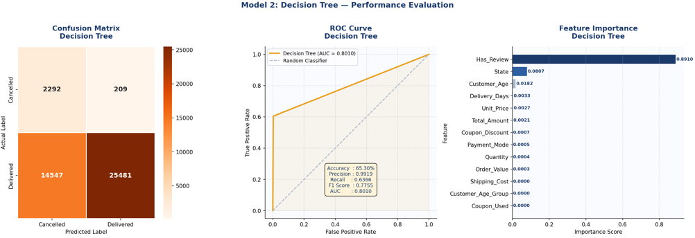
Since review information may only become available after the customer's order experience, this feature may indirectly reveal information about the final order outcome.

Figure 2: Decision Tree — Confusion Matrix, ROC Curve and Feature Importance

6. Model 3 — Random Forest

6.1 Model Description
Random Forest Classifier was implemented as an ensemble learning approach consisting of multiple decision trees.
The algorithm was selected because it can model nonlinear relationships and interactions between variables while generally providing greater robustness than an individual decision tree.

6.2 Performance Results
Performance Metric | Score
Accuracy | 65.55%
Precision | 0.9912
Recall | 0.6397
F1 Score | 0.7775
ROC-AUC | 0.8006
Random Forest achieved the highest Accuracy and F1 Score among the three initial models.

Feature Importance
Feature | Importance
Has_Review | 0.860128
State | 0.038844
Customer_Age | 0.026662
Delivery_Days | 0.022752
Coupon_Discount | 0.010608
The continued dominance of Has_Review provided further evidence that the initial models could be relying heavily on information related to the eventual order outcome.

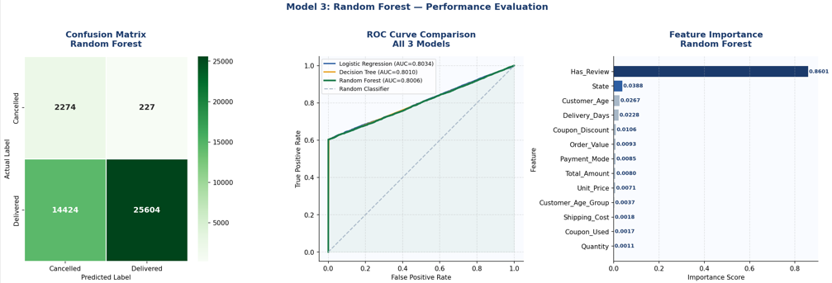
Figure 3: Random Forest — Confusion Matrix, ROC Comparison and Feature Importance

7. Comparative Model Evaluation

7.1 Initial Model Comparison
Model | Accuracy | Precision | Recall | F1 Score | ROC-AUC
Logistic Regression | 62.63% | 1.0000 | 0.6029 | 0.7523 | 0.8034
Decision Tree | 65.30% | 0.9919 | 0.6366 | 0.7755 | 0.8010
Random Forest | 65.55% | 0.9912 | 0.6397 | 0.7775 | 0.8006
Based solely on the initial metrics, Random Forest appeared to be the strongest model because it achieved the highest Accuracy, Recall, and F1 Score.
However, the analysis did not end at performance comparison. Feature importance revealed a potential data leakage issue, requiring further investigation.

8. Data Leakage Investigation

8.1 Identification of Potential Leakage
Two features were considered potentially problematic:

Has_Review
The existence of a review can be associated with an order that has already progressed through the customer experience. Therefore, it may not be a valid predictor when the objective is to predict cancellation before the order outcome occurs.

Delivery_Days
Delivery duration is calculated using delivery information. Since it depends on the delivery event itself, it is not an appropriate predictor for determining whether an order will ultimately be delivered or cancelled.
Including such variables can result in target leakage, where the model indirectly receives information about the target during training.

9. Leakage-Safe Modeling
To obtain a more realistic predictive assessment, Has_Review and Delivery_Days were removed.
The revised model therefore used only features that could reasonably be available before the final order outcome.
The leakage-safe feature set contained 11 variables:
Quantity
Unit_Price
Order_Value
Shipping_Cost
Coupon_Discount
Total_Amount
Customer_Age
Coupon_Used
Payment_Mode
State
Customer_Age_Group
The same train-test split, feature scaling process, SMOTE procedure, and classification algorithms were retained to ensure a fair comparison.

10. Leakage-Safe Model Results
Model | Accuracy | Precision | Recall | F1 Score | ROC-AUC
Logistic Regression | 47.80% | 0.9410 | 0.4752 | 0.6315 | 0.5014
Decision Tree | 93.95% | 0.9412 | 0.9980 | 0.9688 | 0.4974
Random Forest | 50.74% | 0.9399 | 0.5092 | 0.6605 | 0.4988
At first glance, the Decision Tree appears to perform extremely well based on its 93.95% accuracy and 0.9688 F1 Score. However, these values must be interpreted in the context of the class distribution.

11. Baseline and Error Analysis
The dataset contains 94.12% Delivered orders.
A baseline model that predicts Delivered for every order would therefore achieve an accuracy of 94.12%.
The leakage-safe Decision Tree obtained:
Accuracy = 93.95%
This is slightly lower than the majority-class baseline.
Furthermore, its performance for cancelled orders was extremely poor:
Metric for Cancelled Class | Score
Precision | 0.08
Recall | 0.00
F1 Score | 0.01
Therefore, the Decision Tree did not meaningfully identify cancelled orders despite its apparently high overall accuracy.
This demonstrates the limitation of relying solely on accuracy when working with highly imbalanced classification datasets.

12. Original vs Leakage-Safe AUC Comparison
Model | Original AUC | Leakage-Safe AUC
Logistic Regression | 0.8034 | 0.5014
Decision Tree | 0.8010 | 0.4974
Random Forest | 0.8006 | 0.4988
The reduction in AUC from approximately 0.80 to approximately 0.50 across all three models is the most significant finding of the analysis.
An AUC close to 0.50 indicates that the leakage-safe models performed approximately at random when distinguishing between delivered and cancelled orders.

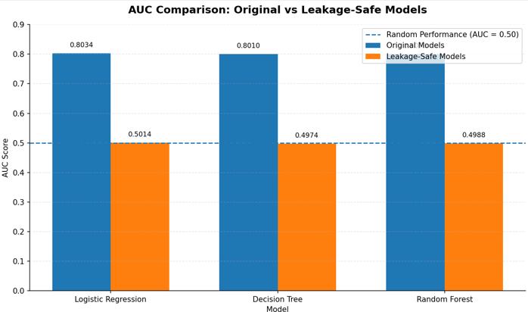
Figure 4: Original vs Leakage-Safe ROC-AUC Comparison

13. Discussion
The analysis demonstrates that model evaluation requires more than comparing accuracy values.
The initial models produced apparently reasonable results, with Random Forest achieving an Accuracy of 65.55% and an F1 Score of 0.7775. However, the feature-importance analysis identified Has_Review as the dominant feature, accounting for approximately 86% of the Random Forest's feature importance.
The subsequent leakage-safe experiment produced substantially lower ROC-AUC scores, with all three models achieving values near 0.50.
This indicates that the remaining pre-order attributes were insufficient to provide reliable discrimination between cancelled and delivered orders.
The experiment therefore demonstrates the importance of:
- Detecting data leakage.
- Evaluating class-specific performance.
- Comparing models against a baseline.
- Considering multiple performance metrics.
- Distinguishing between statistical performance and practical usefulness.

14. Limitations
The following limitations were identified during the analysis:

14.1 Class Imbalance
Cancelled orders represented only 5.88% of the dataset, making cancellation detection difficult.

14.2 Limited Predictive Information
The available pre-order variables did not provide sufficient information for reliable cancellation prediction.

14.3 Potential Data Leakage
The initial feature set contained information that may not be available at prediction time.

14.4 Feature Encoding
Label Encoding was used for categorical variables. Although suitable for this experiment, alternative encoding techniques such as One-Hot Encoding could be explored in future experiments.

14.5 Limited Algorithm Selection
Only three standard classification algorithms were evaluated. More advanced machine learning methods may provide additional insights.

15. Recommendations for Future Work
Future iterations of the project could improve prediction quality by introducing additional features that are genuinely available before order completion.
Potential features include:
- Customer's historical cancellation rate
- Previous successful orders
- Customer purchase frequency
- Historical payment behavior
- Product category
- Seller performance
- Inventory availability
- Estimated delivery time
- Delivery location and distance
- Historical cancellation rate by seller
- Historical cancellation rate by product
- Order day and time
Advanced algorithms such as Gradient Boosting, XGBoost, LightGBM, and other ensemble methods could also be evaluated.
Future experiments should focus on Cancelled-class Recall, F1 Score, Precision-Recall AUC, and cost-sensitive evaluation rather than relying primarily on overall accuracy.

16. Conclusion
The Week 4 analysis successfully implemented a complete supervised machine learning workflow for e-commerce order classification.
Three classification models—Logistic Regression, Decision Tree, and Random Forest—were developed and evaluated using standardized training and testing procedures.
The initial experiment produced moderate predictive performance, with Random Forest achieving the highest overall Accuracy of 65.55% and F1 Score of 0.7775. However, detailed feature-importance analysis revealed potential data leakage through post-outcome variables, particularly Has_Review and Delivery_Days.
A second leakage-safe experiment was therefore conducted after removing these variables. The resulting models achieved ROC-AUC values between 0.4974 and 0.5014, demonstrating performance close to random classification.
The analysis concludes that the existing pre-order features do not provide sufficient predictive information to reliably distinguish cancelled orders from delivered orders. The experiment also highlights the importance of addressing class imbalance, identifying target leakage, selecting meaningful evaluation metrics, and comparing model performance against an appropriate baseline.
Overall, this project demonstrates not only the implementation of machine learning algorithms but also the importance of critical model validation and responsible interpretation of predictive results.

